Function Point Approach: System Size

**System Components**

|  |  |  |  |  |  |
| --- | --- | --- | --- | --- | --- |
|  | | **Complexity** | | |  |
| **Description** | **Total Number** | **Low** | **Medium** | **High** | **Total** |
| Inputs | 4 | 1 * 3 | 2 * 4 | 1 * 6 | **17** |
| Outputs | 4 | 0 * 4 | 1 * 5 | 3 * 7 | **26** |
| Queries | 5 | 1 * 7 | 2 * 10 | 2 * 15 | **57** |
| Files | 5 | 1 * 7 | 2 * 10 | 2 * 15 | **57** |
| Program  Interfaces | 6 | 2 * 5 | 1 * 7 | 3 * 10 | **47** |
| **TOTAL UNADJUSTED FUNCTION POINTS (TUFP)** | | | | | **204** |

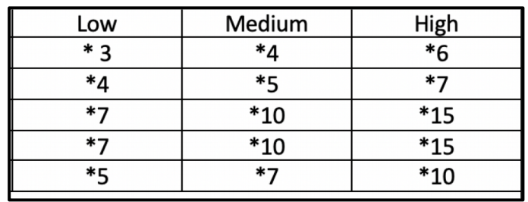

**Overall System**

|  |  |
| --- | --- |
| Data communications | 2 |
| Heavy use configuration | 0 |
| Transaction rate | 0 |
| End-user efficiency | 0 |
| Complex processing | 0 |
| Installation ease | 0 |
| Multiple sites | 0 |
| Performance | 1 |
| Distributed functions | 0 |
| Online data entry | 2 |
| Reusability | 1 |
| Operational ease | 1 |
| Extensibility | 0 |
|  |  |
| **Total Processing Complexity (PC)** | **7** |

**Adjusting Function Points**

Adjusted Processing Complexity (PCA) = 0.65 + (0.01 * 7) = 0.72

Total Adjusted Function Points: 0.72 * 204 = **147**

**Total Adjusted Function Points: 147**

**Lines of Code**

Javascript ~21 LOC/FP -> 147 * 21 = 3,087

**JavaScript Lines of Code: 3,087**

**Effort Required**

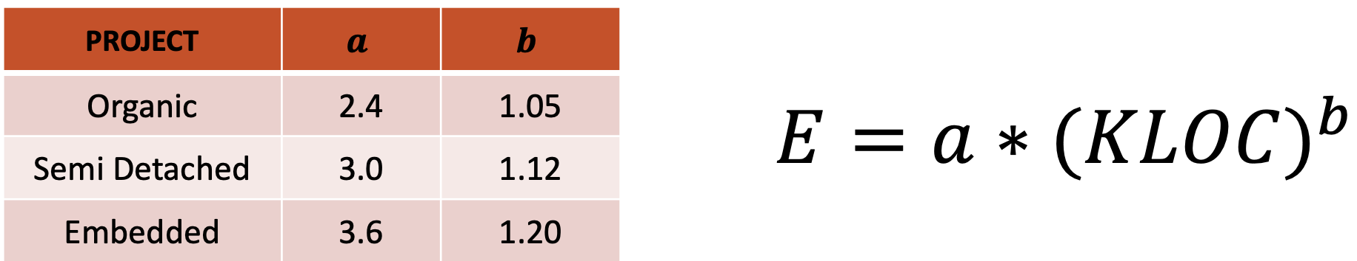

**Our project is organic**

E = 2.4 * (3.087)^1.05 = 7.8

**The Effort required is 7.8 person-months**

**Time Required**

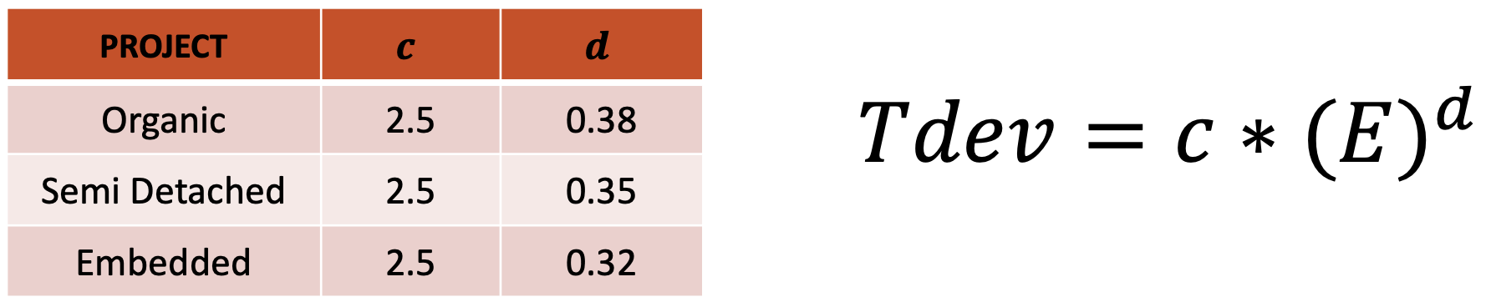

**Our project is organic**

Tdev = 2.5 * (7.8)^0.38 = 5.5 months

**The Time of Development required is 5.5 months**